Name: Truong Dang Truc Lam  
ID: B2111933   
Class: CT209H-M04933

**LAB 1**

**Installing and Configuring Windows Server 2019  
and Domain Controller**

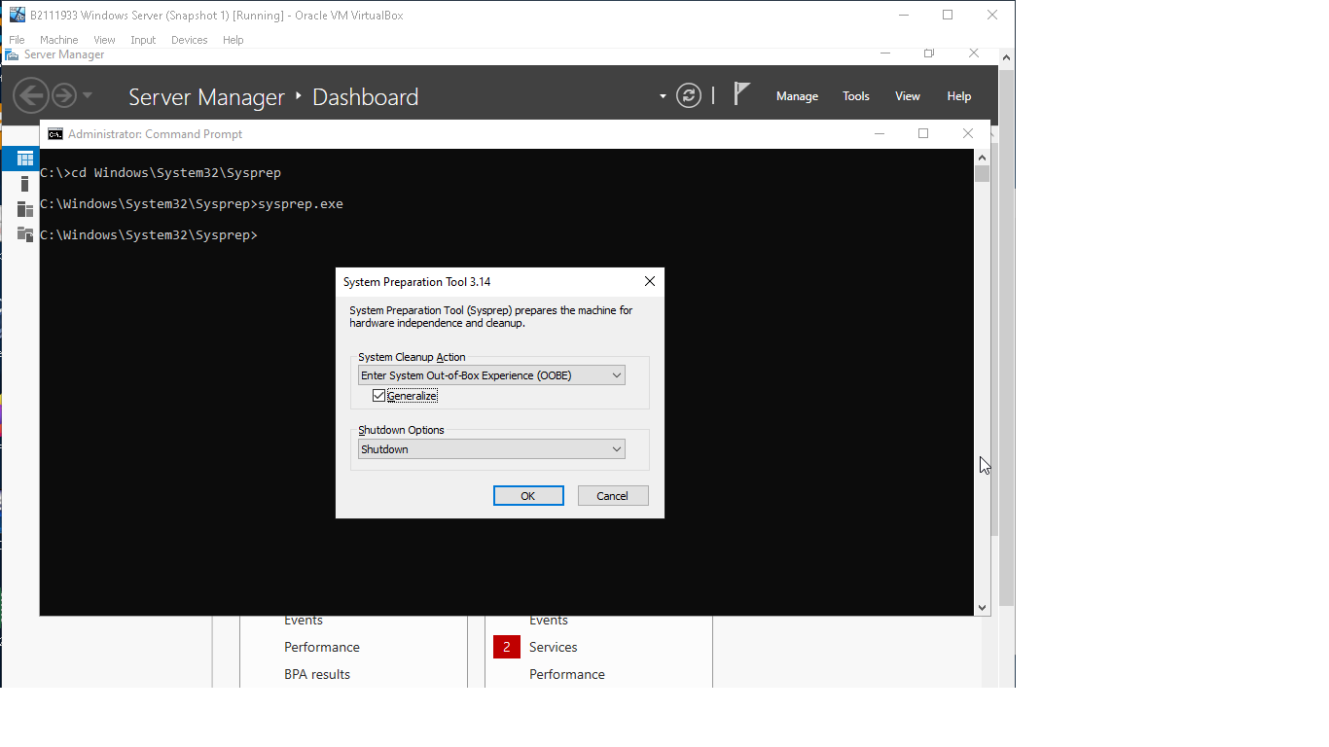

Sysprep is a Windows utility that is used to generalize an image of the OS. This process removes specific information such as installed drivers and the computer security identifier (SID), making the image suitable for deployment to multiple computers.

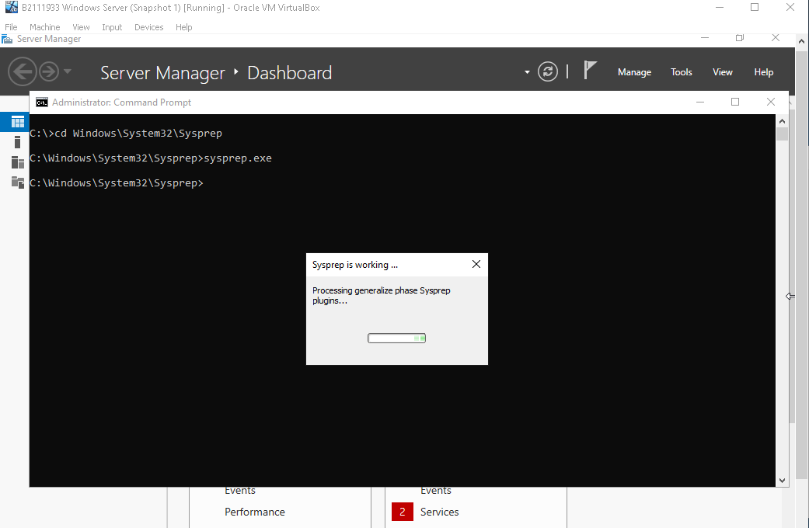

Sysprep removes unique identifiers that tie the image to a specific computer, allowing it to be reused on different hardware. We will create a Master Disk to serve as a template for our virtual machines DC1 and DC2.

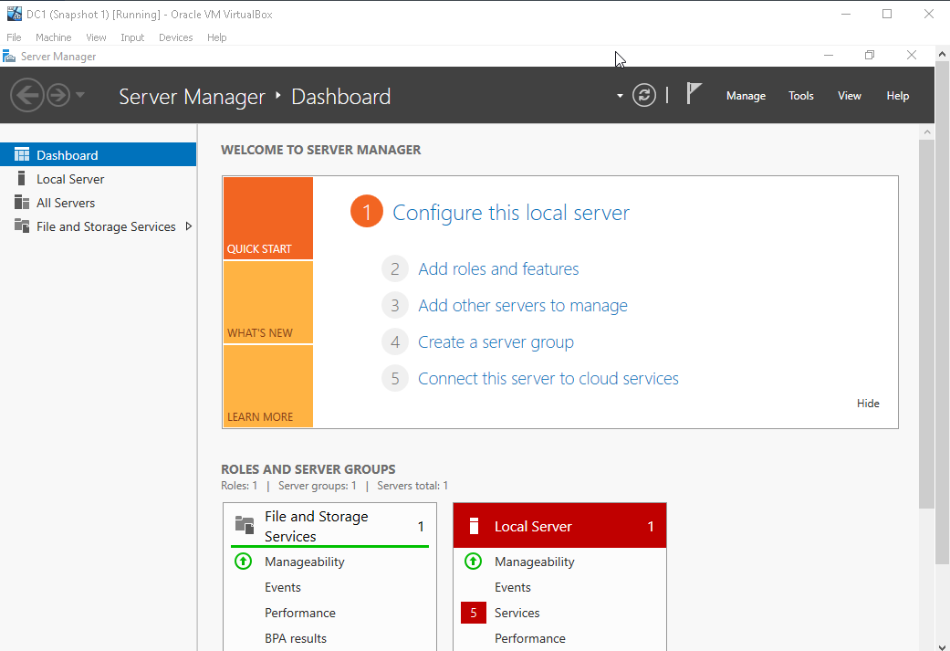

DC1 is created with the existing Master Disk.



I will config the network of my Domain Controllers   
according to the IP address range that my teacher provided.

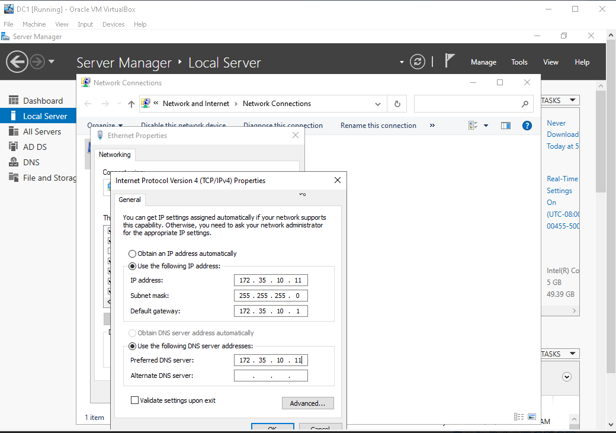

This is the IPv4 configuration of my DC1.

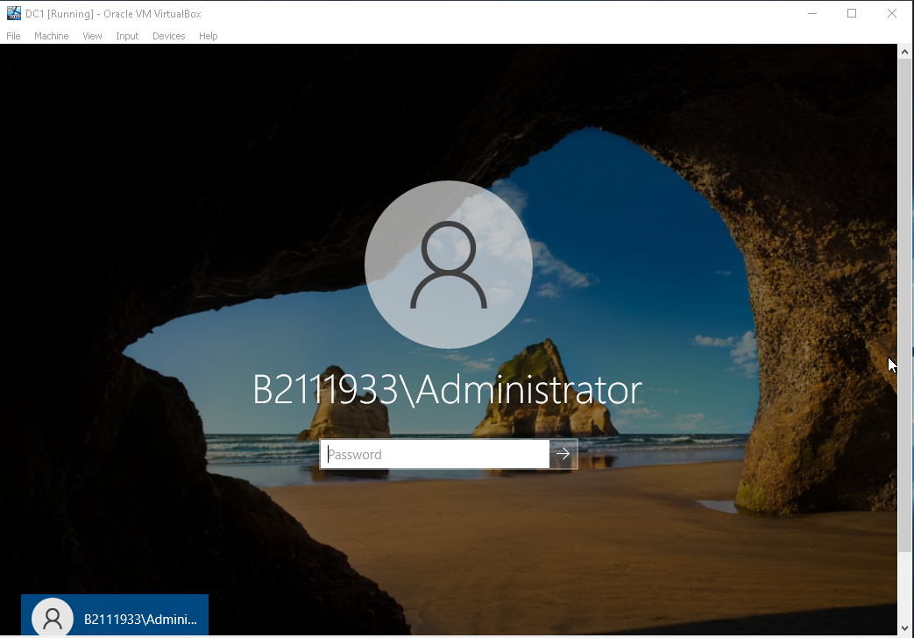

A forest is a logical grouping of Active Directory domains that share a common schema, configuration, and global catalog.

The root domain is the top-level domain that serves as the administrative foundation for the entire forest. It's the domain where those forest’s components are stored.

We create a new Active Directory environment by promote DC1 to a new forest. The root domain name is B2111933.local.

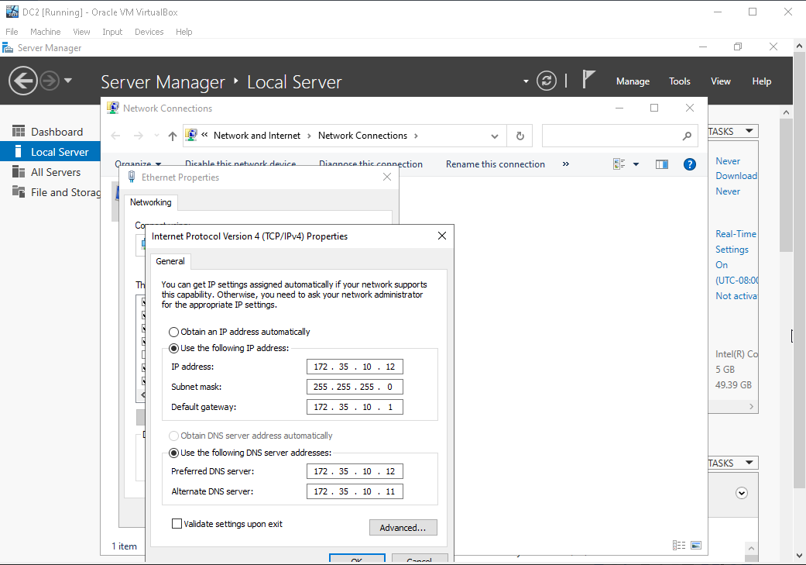

This is the IPv4 configuration of my DC2.

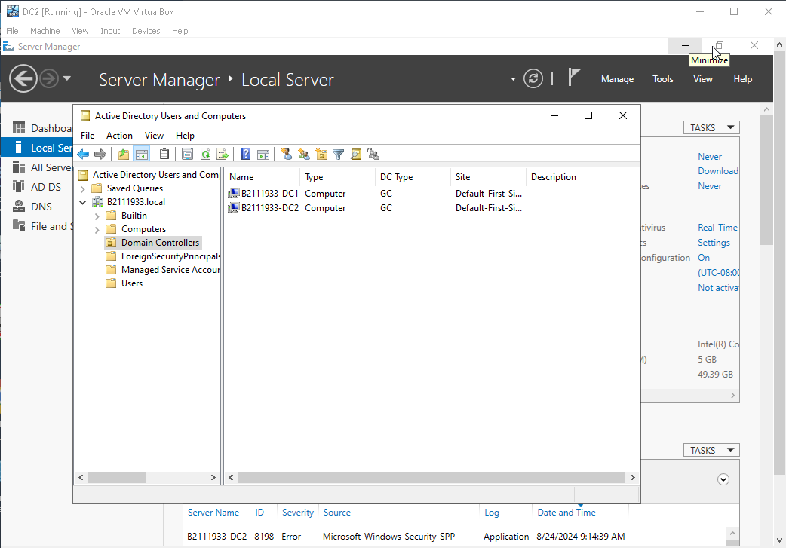

Finally, we join DC2 to the Active Directory Domain. We can see the list of Domain Controllers in the same Active Directory Domain (including DC1 and DC2).